I Am Legend * Final Product
Drawing understanding of literature through popular media.
Choose one of the following products. Some invite a partner. Not all equal the maximum score based on the level of difficulty.

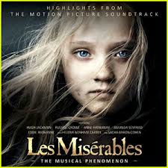
- I AM LEGEND – The Soundtrack : 1 man job /
Requirements:
- Album Cover : Your cover should hook your
Audience & offer insight into the “story”. The
title and author should be included, as well as
a tagline from the book itself (quote it). Your
cover should be original.
- Soundtrack: 5 songs presented that you feel
Represent the story on different levels: character, conflict, climax, irony, etc.
You should provide the title and artist of each song, with a small paragraph explaining WHY / HOW this song connects. For this, you MUST embed evidence from the song’s lyrics.
- Presentation: A CD case
Rubric:
A = has all requirements. Cover: has creativity, neatness, quality, depth. / Songs reveal depth and coverage of the novella on different levels. / Writing shows depth and properly written embedded evidence from the song.
B= has all requirements, but cover lacks originality or depth. Songs are focused mainly on one or two aspects of novella. Writing connection is obvious and weakly written.
C= missing 1 required component or has all components, but it messy, shows haste when doing, lacks depth of thought. Songs are weakly connected or focused on one or two aspects of novella. Writing connection is weak due to mere paraphrasing or weak commentary.

- Focus: Analysis / Cross-over / Theme / Plot

- I AM LEGEND the MOVIE AD / POSTER : 1 man job /
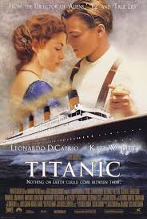
Requirements:

Size: 16X20 or larger

PATHOS:
Visual: Captures theme/conflict/character
Tagline: quote from book

ETHOS:
Cast: Protagonist:___________________
Sub Character/s: _____________
_____________
Rating of Film: for what audience / reason?
Director? Production Company?

LOGOS:
What proof can you offer that proves it is a
Must see movie? That it is worth seeing?

Rubric:
A= all appeals are present and effective on the
Poster. It is persuasive. It is neatly done, has a
High quality to it, effort is evident, and it has
Depth.

B= all appeals are present and effective. The poster doesn’t have that WOW factor. It could use more work and time to get it over the edge. There is a good quality to it, and overall, it is effective.

C= all appeals are present, but not necessarily effective. The work looks messy and/or more proofreading is needed. It is hardly persuasive. It lacks quality and thought.

- Focus: Analysis – Persuasion – Appeals

- I AM LEGEND the MOVIE TRAILER : 2 man job /

Requirements:

Delivery: Moviemaker, Quicktime, etc.
Time: 30 – 60 sec.

PATHOS:
Movie Clips: Highlights the conflict and climax of film that establishes interest in the audience. (can be acted out / taken from bits and pieces of other films)

Main Tagline: quote from book

Music: audio that emphasizes mood / content of trailer (clips of action)

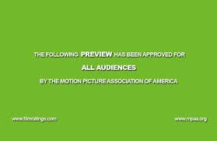
ETHOS:
Cast: Protagonist: ___________________
Sub Character/s: _____________
_____________
Rating of Film: for what audience / reason?
Director? Production Company?

LOGOS:
What proof can you offer that proves it is a
Must see movie? That it is worth seeing?
When movie is coming out - date.

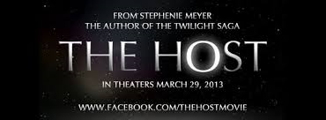

VISIT - http://www.comingsoon.net/trailers to see trailers for upcoming movies for ideas.
- Focus: Persuasion / Appeals / Analysis

