Alumni Snapshot Campaign
For 2021!
Dear SHS Graduate,
You have been selected as part of the Alumni Snapshot Campaign for Sharyland High School for 2021! This campaign aims at promoting the attendance of our SHS Alumni (YOU!) at universities nationwide or in military service. Our secondary aim is to encourage our current SHS students to get a post-secondary education after high school graduation.
Your framed poster-sized photo will be placed in a Sharyland High School building to promote college awareness or service in the military. We’ll also blast it via SISD social media.
How can you help?
- Have someone take one-two digital camera pictures of you at the university you are attending. The pictures should be outdoors with a university building in the background or on your military base.
- Email the Sharyland High School librarian with the following information:
  - Your full name
  - Full name of the college you are attending, city and state or
  - Full name of the branch of military you are enlisted in
  - Your intended major/minor course of study
  - Your intended career goal
  - A short statement granting permission to use your photo to promote college awareness or military service at SHS through the Alumni Snapshot Campaign
- Attach your pictures to the email (jpeg)
- Submit your information by October 30th, 2021 to the librarian:
  - Nicole Cruz (ncruz@sharylandisd.org)
- Please email or call us at (956) 580-5300 Ext 1208 if you need additional information
We wish you a terrific Fall Semester and hope that you will help us with this exciting endeavor!
2020 ALUMNI REPRESENTED BELOW

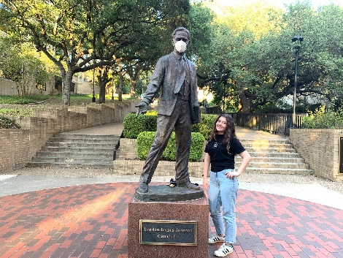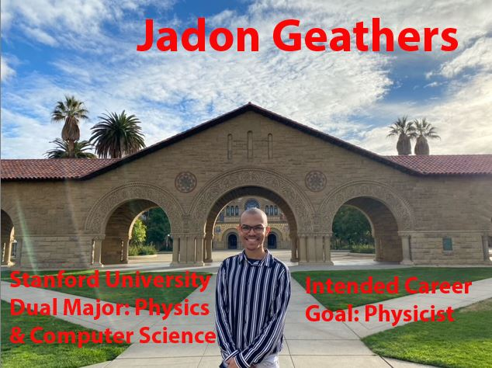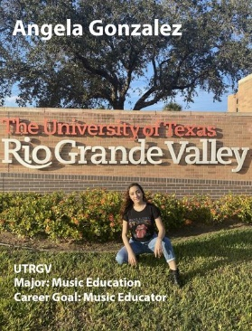
Alyssa Cavazos Anastasia Cruz Jadon Geathers Angela Gonzalez

